**Title Page**

**Title**: Trends and Patterns of Human Papillomavirus Vaccination Acceptance: A Study on Immunizations Administration Records on Long Island, 2012-2023.

**Abbreviated Title**: Trends and Patterns of Human Papillomavirus Vaccination Study on Long Island, 2012-2023

**Authors:**

Zihan Ding1, Jianyuan Deng PhD2, Linda Mermelstein, MD, MPH3, Barbara Nemesure, PhD3,4, Tyler Osborne1, Fusheng Wang PhD1,2

1. Department of Computer Science, Stony Brook University, Stony Brook, NY,
2. Department of Biomedical Informatics, Stony Brook University, Stony Brook, NY,
3. Stony Brook Cancer Center, Stony Brook, NY,
4. Department of Family, Population and Preventive Medicine, Stony Brook Medicine, Stony Brook, NY

**Corresponding Author**

Fusheng Wang PhD

Department of Biomedical Informatics

Department of Computer Science

Stony Brook University

2313D Computer Science

Stony Brook, NY 11794-8330

Tel: (631)632-2594

Email: [fusheng.wang@stonybrook.edu](mailto:fusheng.wang@stonybrook.edu)**Abstract**

**Introduction:**  The Advisory Committee on Immunization Practices advised vaccinating young adult females against Human Papillomavirus (HPV) in 2006, and extended this recommendation to males in 2011, aiming to prevent HPV-related cancers and genital warts. As these preventative measures have spread rapidly in recent years, understanding vaccination acceptance patterns and disparities is essential for informing targeted public health interventions. The purpose of this study is to explore the demographic disparities, temporal trends, and geographical patterns of HPV vaccine administration rate by analyzing large-scale immunization registry vaccine data for Long Island (LI), New York (NY).

**Methods:** The vaccine registration data retrieved from the New York State Immunization Information System (NYSIIS) was used to assess the HPV vaccine administration rate from 2012 to 2023. Patients’ demographic information and regional variations were evaluated to identify the disparities between different groups of people on Long Island. The analysis was conducted between 2023 and 2024.

**Results:** The HPV vaccination rate among teenagers between the ages of 9 and 13 on Long Island demonstrates a growth of 284.43% from 2012 to 2019 and a slight decrease of 5.04% around 2020. Around 68.07% of individuals received their first dose before their 15th birthday and 24.95% of them followed the recommended routine to receive 2 doses in half a year. Spatially, eastern Long Island consistently holds a higher HPV vaccination rate than west of the North Shore.

**Conclusions**: There is a rising trend of HPV vaccine coverage on Long Island among teenagers from 2012 to 2023 with a modest drop in HPV vaccination rates among teenagers led by the COVID-19 pandemic around 2020 and the uneven distribution of HPV-vaccinated patients on Long Island. Additional attention is called to be paid to the regions with the lowest uptake rates to prevent HPV-related cancers.

**Introduction**

Human Papillomavirus (HPV) infection, which is the most common sexually transmitted infection, causes approximately 33700 cases of cancer every year in the United States.1-23 The HPV vaccine is designed to prevent infection by certain types of HPV, which can lead to six types of cancer (anal, cervical, oropharyngeal, vulvar, vaginal, and penile) and genital warts. It is one of the most effective ways to prevent HPV-related diseases.4,5 The vaccine is typically administered through a series of injections. In the United States, the HPV vaccine is widely available and recommended for adolescents and young adults.6 Various campaigns and initiatives have been launched to increase awareness and uptake of the vaccine.4,7 In 2022, 38.6% of children between the ages of 9 and 17 had received one or more HPV vaccination doses.8 Additionally, school-based vaccination programs and outreach efforts have been utilized to reach adolescents globally and are standard in many countries.9,10

The HPV vaccination schedule follows a recommended protocol maximizing long-term protection against HPV-related diseases. Guidelines established by the New York State Department of Health (NYSDOH) support the 'Start at 9' initiative by the National Human Papillomavirus Vaccination Roundtable, promoting the recommendation for routine HPV vaccination to commence ages 11 - 12 starting as early as age 9.4,11 When the HPV vaccine is given to individuals before their 15th birthdays, only two doses, separated by a minimum of 6 months, are required to complete the vaccination series.  However, for those who initiate the HPV vaccination series aged 15 or older, or individuals aged 9 to 26 with a weakened immune system, three doses are necessary for full protection. In the case of three doses, the second dose should be administered 1 to 2 months after the first, and the third dose should be given at least 6 months after the initial dose.12 The minimum interval between the second and third doses is 12 weeks, and between the first and third doses is 5 months. Vaccination schedules may be used by healthcare providers to educate parents and patients about the importance of completing the full series for maximum benefit.13,14

In New York, like in many other states, efforts have been made to ensure accessibility to the vaccine through healthcare providers, clinics, and public health programs. The NY state government has provided various measures to cover the expenses of HPV vaccination to promote its uptake among young people.15 Both women’s and men’s HPV vaccination coverage in New York State is higher than the average HPV vaccination rate nationally according to the official report released by NYSDOH in 2020.16

The purpose of this study is to better understand the HPV vaccination trends and patterns on Long Island (Generally including Suffolk County and Nassau County) by using data analytics and statistical tools. LI holds a diverse population with varying socio-economic backgrounds, cultural norms, and healthcare access, which can profoundly influence vaccination rates.16 The Bureau of Immunization within the New York State Department of Health (NYSDOH) is dedicated to enhancing the well-being of children in New York State by minimizing or eradicating vaccine-preventable diseases that impact the state's youth.18,19 This helps epidemiologic researchers and health providers understand how interventions and demographics affect vaccine uptake and lets them tailor public health efforts to Long Island's specific needs. Additionally, analyzing geographic patterns of vaccination may help identify the impact of socioeconomic differences, cultural norms, and healthcare access on HPV vaccination rates. Therefore, focusing on HPV vaccination patterns on Long Island enables a comprehensive understanding of regional dynamics and facilitates targeted public health strategies to improve vaccine uptake and reduce the burden of HPV-related cancer on Long Island.

**Methods**

Data Sources

This study utilized patient vaccination data from NYSIIS (New York State Immunization System), managed by the New York State Department of Health, collecting immunization records for individuals from 2008 to prevent vaccine-preventable diseases among children in the state.18 To protect patient privacy, the NYSDOH data presents case counts associated with zip codes rather than individual addresses.20 Our research is centered on  zip codes belonging to Long Island.21 We filtered data using “Gardasil” to identify patient visits for the HPV dose. Due to experimental requirements, we also gathered Tdap (Tetanus, Diphtheria, and Pertussis) vaccine-relevant data. Only people who received either HPV or Tdap vaccinations were included in our analysis. In total, 2173576 patients’ visit records, and 1120113 unique patients were included in our analysis. The dataset also contained patient-level information, including demographics, vaccination months and years, provider information, and the patient’s zip code, among other details.

In New York State, children enrolled in daycare as well as those in pre-K through 12th grade are obligated to receive all necessary vaccines including Tdap doses according to the recommended timetable to be eligible for school attendance.22 In our study, we use the number of school-aged children who got the Tdap vaccination as the benchmark to calculate the HPV vaccination rate among teenagers aged 9-13 years. Overall, we will use the number of teenagers aged 9-13 years who receive the HPV vaccination as the numerator, and the number of teenagers aged 9-13 years who either received the HPV or Tdap vaccinations as the denominator.

Patients Demographic Analysis

We aggregated the individual data by the unique client ID and sorted by the vaccination year and month. Only initial visits are counted if a patient has multiple visits.  In our study, we utilize patient-level data from 2008 to 2023. Our target group consists of children aged 9 to 13. In order to include all the Tdap vaccine data in this timeframe, we need to exclude the year range 2008 to 2011 as there will be missing Tdap records before the NYSIIS is established thus may cause the inaccurate denominator when calculating the rate.

We will conduct a comprehensive analysis examining gender, race, and ethnic disparities among those vaccinated patients. This section will present an analysis of HPV vaccination temporal trends across diverse demographic groups on Long Island.

 Temporal Analysis over 2012 to 2023

All the patient-level data were aggregated by the vaccine year and month from those time-series data to visualize the trend and seasonality. In this section, if a person receives multiple doses, only the initialized time will be used in the temporal analysis. The number of children from 9 to 13 who either received Tdap or HPV vaccines in a specific year was counted as the denominator and the numerator was the number of children from 9-13 who received the HPV vaccination. The result will conclude the HPV vaccination rate on Long Island and separately from Suffolk and Nassau from 2012 to 2023. Additionally, we will analyze seasonal patterns of vaccination to explore climate-related impacts on vaccine uptake.

Geographical Spatial Analysis

This study’s scale is on Long Island, generally including Suffolk County and Nassau County, and we will visualize the zip code level spatial distribution of HPV vaccination rate calculated by the formula provided in previous sections using geographical maps. The shade of color in each block represents the rate of HPV vaccination. All maps were generated using ArcGIS Desktop 10.5 (Esri, Redlands CA).

Approval was obtained from the NYS Department of Health and a Stony Brook University IRB before dataset acquisition and analysis. As the data were obtained from an administrative database maintained by NYS, no informed consent was needed for study participation. All study analyses were completed between 2023 and 2024.

**Results**

HPV Vaccination Patients Demographic Overview

Table A provides an overview of patient demographics, including various groups categorized by demographics. Each row in the table represents a distinct demographic category, while columns display the number of HPV-vaccinated patients in that group (p < 0.0005). The table indicates that there is a slightly lower number of female patients compared to male patients. In our database, the largest group as defined by race is white, followed by Black and Asian (all p < 0.0005).

Figure A illustrates the age distributions of different groups of patients receiving the HPV vaccination. The histogram reveals that most patients receive their first dose between 10 and 14 years of age. There is a slight variation between genders, with females (year 10-11) initiating vaccination slightly earlier than males (year 11 to 12). Hispanic individuals tend to start their HPV vaccination series sooner than non-Hispanic individuals.

Temporal Trend and Doses Series Completeness Analysis

Figure B indicates the HPV vaccine initialization rate on Long Island among children aged 9-13 years from 2012 to 2023. The overall rate went up by 284.43% from 2012 to 2019 and is followed by a slight decline (5.04%) in 2020 and 2021. This may have been caused by the Covid-19 pandemic: the rate rose smoothly from 2021 to 2023, when the acute phase of the pandemic ended. This trend was evaluated via ordinary least squares (OLS) regression and emphasizes the significance of the linear trend (p < 0.0005).

In subfigure A, both males and females experienced a similar trend but the starting point for boys is slightly lower than girls. The approval of HPV vaccination for girls began in 2006, while it was recommended for boys until 2011.5,23 This discrepancy may lead to boys initiating the vaccination later than girls. In subfigures B and C, those two counties show similar trends from 2012 to 2023 (p > 0.05). Both have a statistically significant correlation to all gender rate over the years. Disparities among different racial and ethnic groups are shown in subfigure D: non-Hispanic and white people’s HPV vaccination rates are consistently lower than people who identified themselves as Black and Hispanic among those children aged 9-13 years. Efforts to improve vaccination awareness and access are crucial for all racial and ethnic groups. Figure B also indicates HPV vaccinations are mostly offered to children in the summer as public and private schools in New York state require vaccination at the entry of school in fall.22 This can be helpful for the health provider and researcher to gain more attention in this period.

Towards the completeness of the whole vaccination series, the nested pie chart A in Figure C represents the dose schedule preference among all the HPV vaccination patients in our database. According to the HPV vaccination schedule guideline announced by the CDC, we divided all the patients by the initialization age. Initial age < 15 and initial vaccination after the 15th birthday was presented by the red and blue parts in the figure. Around 45.1% of the first group patients completed the recommended doses in 12 months and 37% of the second group finished their whole 3 doses series. Adolescents receiving their first dose before age 15 are more likely to finish than teens starting later, with over 82.58% of the under-15 group completing the series compared to about 45.75% of the over-15 group. Subfigures B and C illustrate the initialization rate and complete rate disparities among gender, race, and ethnicity groups. The number on the bars represents the portion of completed patients towards all patients who initiated their HPV vaccination schedule. Of those who started the vaccine, about 70.82% of them completed the full vaccination sequence. Girls finish the vaccine series slightly more often than boys and Asians have the highest completion rate at nearly 75%.

Geographic Patterns in Zip code Level

We picked 8 typical years of geographical maps here to represent the spatial distribution of HPV vaccination administration rate on Long Island among adolescents aged 9-13 years. In the significant test, OLS regression was utilized to verify the linear trend and over 82% of the zip code area rate has a p < 0.05 and the linear trend has been proved. For the overall difference, we use F-test (p >0.05) which means we cannot reject the hypotheses that are not the same among those zip code areas.  It can be seen that the HPV vaccination rate on the eastern side of Long Island consistently exceeds that on the western side. Especially the western parts of the north shore. Riverhead (zip code 11901) became the highest HPV vaccination rate area on Long Island. This can be caused by various factors such as socioeconomic status, healthcare access and awareness, culture and social norms, and also media influence. There is also a densely populated area in the eastern region, near the north shore; however, significant disparities exist. This information can raise awareness among healthcare providers and researchers on the North Shore, prompting them to monitor and address the spread and popularity of HPV vaccination in their respective cities. A collaborative effort involving healthcare professionals, policymakers, educators, and the community is essential for successful HPV vaccination promotion on Long Island.

**Discussion**

This research fills the knowledge gaps related to HPV vaccination trends and patterns on Long Island by applying epidemiological and data analytics techniques to assess the geographic, temporal, and personal demographics of HPV-vaccinated individuals. The HPV vaccination rate across Long Island has gradually increased over the past decade with a slight drop during the COVID-19 pandemic. This trend aligns with national increases in HPV vaccination rates, as reported by the New York State Department of Health and the Centers for Disease Control and Prevention among teenagers.8,16,24 The child vaccination rate rose each year until 2019, which had the highest rate at about 44.99%. However, when COVID-19 hit in early 2020, the vaccination rate dropped slightly (a 5.04% decrease from 2019 to 2021) in the HPV vaccination rate. Since then, the vaccination rate has gradually recovered but hasn't reached 2019’s maximum rate yet. Another finding is that there are disparities in the HPV vaccination rates among different racial and ethnic groups. For example, Hispanic people had a consistently higher vaccination rate than other ethnicities. Segmenting by zip code, eastern Long Island is doing better than western Long Island with 82% of the ZIP codes testing the linear trend by the OLS regression. These findings support the continued encouragement of early vaccination and call for special efforts on Long Island’s North Shore where fewer school-aged adolescents are getting vaccinated.

Our study adds to what we know from other recent studies in the past decade. The New York State Department of Health releases cancer-related statistics including HPV-related cancer and HPV vaccination every five years, helping us track medium and long-term relationships between HPV vaccination and disease incidence rates.16,24,25 In 2016, Nadja A. Vielot and her team found that older boys and adolescents living in rural areas didn’t get the HPV vaccine as much as other vaccines like Tdap or MenACWY.26 Our findings are similar: boys' and especially older children’s HPV vaccination rates are both quite lower than girls. Erika and her team focus on college students and emphasize that work is needed to increase women’s HPV vaccination rates within the said demographic.27 This aligns with our finding that older teens' HPV vaccination completion rate is significantly lower than that of younger children. Szu-Ta Chen and his team utilized the commercial insurance database in the US and indicated that HPV vaccination coverage among insured children still needs more efforts to improve.28,29 This is like what we saw with different places in Long Island—some areas and some groups required more effort to spread the HPV vaccination. Lastly, Kalyani et al. found that the primary reason for patients not initiating the HPV vaccination is the safety concern.30 We need to put increasing effort into the intervention of unvaccinated teens and also work to correct the false information spreading on social media that greatly influences public opinion.31

Limitations of this study

One limitation of our study pertains to the calculation of HPV vaccination rates among individuals aged 9 to 13 years old. Our analysis relies on using the number of patients who have received the Tdap vaccination as the denominator for calculating HPV vaccination rates within this age group. However, it's important to note that this denominator may not accurately represent the total population within the 9 to 13 age range. Additionally, there is a possibility that patients may have received the Tdap vaccine in other states but received the HPV vaccine in New York State, leading to potential discrepancies in our calculations. These factors introduce bias and limitations to our study's findings, highlighting the need for cautious interpretation and consideration of alternative methodologies for accurately assessing HPV vaccination rates among adolescents.

Another limitation of our study is the potential impact of population migration between the years 2012 and 2023, which falls outside the scope of our control in this experiment. Population migration, whether internal or external, can significantly influence the composition and characteristics of the population under study. Individuals may relocate to different regions or countries for various reasons, such as job opportunities, economic factors, or personal circumstances, leading to changes in the demographics of the population. This demographic shift can introduce bias and confound the interpretation of our findings, particularly when assessing long-term trends in HPV vaccination rates. Moreover, migration patterns may vary across different demographic groups, potentially affecting the representation and generalizability of our study results. Therefore, while our study provides valuable insights into HPV vaccination patterns within a specific timeframe, it is essential to acknowledge the limitations imposed by population migration and consider its potential impact on the validity and reliability of our findings.

Conclusion and Future Works

In conclusion, our study provides valuable insights into the HPV vaccination patterns and trends among adolescents aged 9 to 13 years old on Long Island, New York State. We provided several aspects to reveal the user profiles of the HPV vaccination patients and exhibit the yearly trend of the HPV vaccination rate from 2012 to 2023. Ultimately, our study contributes to the ongoing efforts to promote public health and advance our understanding of HPV vaccination practices among adolescents.

In future research, analysis of HPV vaccination trends and patterns could be more fine-grained such as census tract level.  This could help us learn more about what’s happening in smaller areas. We can also enlarge our research scale to the whole of New York States. This way, we can get a better picture of how many people are getting vaccinated in both cities and the countryside. It’s a great opportunity to assist researchers, health providers, and clinic physicians in understanding the patient's preferences and attitudes towards the HPV vaccination.  Such investigation would inform adaptive strategies for policymakers and healthcare providers to address the pandemic's repercussions on HPV-related health outcomes effectively.

**Conflict of Interest Disclosures**

The authors disclose no conflicts of interest.

**Funding/Support:**

This work was supported by no external funding sources.

**Role of the Funder/Sponsor:**

This work was supported by no external funding sources.

**Dissemination to participants and related patient and public communities:**

There are no plans to disseminate the results of the research to study participants or the relevant patient community.

**References**

1. M. Saraiya et al., “US Assessment of HPV Types in Cancers: Implications for Current and 9-Valent HPV Vaccines,” JNCI: Journal of the National Cancer Institute, vol. 107, no. 6, Jun. 2015, doi: [10.1093/jnci/djv086](https://doi.org/10.1093/jnci/djv086).
2. L. Lin, V. B. Benard, A. Greek, N. A. Hawkins, K. B. Roland, and M. Saraiya, “Racial and ethnic differences in human papillomavirus positivity and risk factors among low-income women in Federally Qualified Health Centers in the United States,” Preventive Medicine, vol. 81, pp. 258–261, Dec. 2015, doi: [10.1016/j.ypmed.2015.08.027](https://doi.org/10.1016/j.ypmed.2015.08.027).
3. M. Roman and J. J. Chen, “Understanding Factors Affecting Health Providers’ Perceptions  of Pharmacist Roles in HPV Vaccine Administration,” SOCIAL WELFARE, vol. 83, no. 4, 2024.
4. L. E. Markowitz et al., “Human papillomavirus vaccination: recommendations of the Advisory Committee on Immunization Practices (ACIP),” MMWR Recomm Rep, vol. 63, no. RR-05, pp. 1–30, Aug. 2014.
5. S. Ljubojević, “The human papillomavirus vaccines,” Acta Dermatovenerol Croat, vol. 14, no. 3, p. 208, 2006.
6. C. L. Ejezie, I. Osaghae, S. Ayieko, and P. Cuccaro, “Adherence to the Recommended HPV Vaccine Dosing Schedule among Adolescents Aged 13 to 17 Years: Findings from the National Immunization Survey-Teen, 2019–2020,” Vaccines, vol. 10, no. 4, p. 577, Apr. 2022, doi: [10.3390/vaccines10040577](https://doi.org/10.3390/vaccines10040577).
7. “American Cancer Society Launches Campaign to Eliminate Cervical Cancer,” American Cancer Society MediaRoom. Accessed: Apr. 23, 2024. [Online]. Available: <https://pressroom.cancer.org/HPVcancerfreelaunch>
8. M. Villarroel, A. Galinksy, P.-J. Lu, C. Pingali, and C. Valenzuela, “Human Papillomavirus Vaccination Coverage in Children Ages 9–17 Years: United States, 2022,” National Center for Health Statistics (U.S.), Feb. 2024. doi: [10.15620cancer data/cdc:145593](https://doi.org/10.15620/cdc:145593).
9. M. B. Shin et al., “Multilevel perspectives on school-based opportunities to improve HPV vaccination among medically underserved adolescents: Beyond school entry mandates,” Human Vaccines & Immunotherapeutics, vol. 19, no. 2, p. 2251815, Aug. 2023, doi: [10.1080/21645515.2023.2251815](https://doi.org/10.1080/21645515.2023.2251815).
10. “HPV vaccination introduction worldwide and WHO and UNICEF estimates of national HPV immunization coverage 20102019.”, [Online]. Available: <https://pubmed.ncbi.nlm.nih.gov/33388322/>
11. “https://www.nyc.gov/site/doh/health/health-topics/human-papillomavirus-hpv.page.”
12. E. Meites, “Use of a 2-Dose Schedule for Human Papillomavirus Vaccination — Updated Recommendations of the Advisory Committee on Immunization Practices,” MMWR Morb Mortal Wkly Rep, vol. 65, 2016, doi: [10.15585/mmwr.mm6549a5](https://doi.org/10.15585/mmwr.mm6549a5).
13. L. E. Widdice, D. I. Bernstein, A. C. Leonard, K. A. Marsolo, and J. A. Kahn, “Adherence to the HPV Vaccine Dosing Intervals and Factors Associated With Completion of 3 Doses,” Pediatrics, vol. 127, no. 1, pp. 77–84, Jan. 2011, doi: [10.1542/peds.2010-0812](https://doi.org/10.1542/peds.2010-0812).
14. “Indian Academy of Pediatrics (IAP) Advisory Committee on Vaccines and Immunization Practices (ACVIP): Recommended Immunization Schedule (2023) and Update on Immunization for Children Aged 0 Through 18 Years”.
15. “NYSDOH HPV web page.” [Online]. Available: <https://www.health.ny.gov/diseases/communicable/human_papillomavirus/#:~:text=The%20New%20York%20State%20Department,9%20years%20as%20routine%20practice.>
16. “HPV-Related Cancer Incidence and HPV Vaccination Rates in New York State, 2015-2019”.
17. E. R. Schoenfeld et al., “covi, Temporal, and Sociodemographic Differences in Opioid Poisoning,” American Journal of Preventive Medicine, vol. 57, no. 2, pp. 153–164, Aug. 2019, doi: [10.1016/j.amepre.2019.03.020](https://doi.org/10.1016/j.amepre.2019.03.020).
18. “New York State Immunization Information System (NYSIIS).” Accessed: Apr. 14, 2024. [Online]. Available: <https://www.health.ny.gov/prevention/immunization/information_system/>
19. E. M. Rosenthal et al., “COVID-19 Vaccination and Hospitalization Among Persons Living With Diagnosed HIV in New York State,” J Acquir Immune Defic Syndr, vol. 93, no. 2, pp. 92–100, Jun. 2023, doi: [10.1097/QAI.0000000000003177](https://doi.org/10.1097/QAI.0000000000003177).
20. G. M. Jacquez and D. A. Greiling, “Local clustering in breast, lung and colorectal cancer in Long Island, New York,” International Journal of Health Geographics, 2003.
21. “Long Island Zip Codes - Zip Codes for Nassau County & Suffolk County | LongIsland.com.” Accessed: Apr. 14, 2024. [Online]. Available: <https://www.longisland.com/zip-codes.html#google_vignette>
22. “School Immunization Requirements.” Accessed: May 13, 2024. [Online]. Available: <https://www.health.ny.gov/prevention/immunization/schools/school_vaccines/>
23. “What Is the HPV Vaccine?,” Cleveland Clinic. Accessed: Apr. 15, 2024. [Online]. Available: <https://my.clevelandclinic.org/health/treatments/21613-hpv-vaccine>
24. “HPV-Related Cancer Incidence and HPV Vaccination Rates in New York State, 2013-2017”.
25. “Cancer Data and Statistics.” Accessed: Apr. 29, 2024. [Online]. Available: <https://www.health.ny.gov/statistics/cancer/>
26. N. A. Vielot, A. M. Butler, M. A. Brookhart, S. Becker-Dreps, and J. S. Smith, “Patterns of Use of Human Papillomavirus and Other Adolescent Vaccines in the United States,” Journal of Adolescent Health, vol. 61, no. 3, pp. 281–287, Sep. 2017, doi: [10.1016/j.jadohealth.2017.05.016](https://doi.org/10.1016/j.jadohealth.2017.05.016).
27. E. L. Thompson, C. A. Vamos, C. Vázquez-Otero, R. Logan, S. Griner, and E. M. Daley, “Trends and predictors of HPV vaccination among U.S. College women and men,” Preventive Medicine, vol. 86, pp. 92–98, May 2016, doi: [10.1016/j.ypmed.2016.02.003](https://doi.org/10.1016/j.ypmed.2016.02.003).
28. L. A. Blewett, K. T. Call, J. Turner, and R. Hest, “Data Resources for Conducting Health Services and Policy Research,” Annu Rev Public Health, vol. 39, pp. 437–452, Apr. 2018, doi: [10.1146/annurev-publhealth-040617-013544](https://doi.org/10.1146/annurev-publhealth-040617-013544).
29. S.-T. Chen, K. F. Huybrechts, B. T. Bateman, and S. Hernández-Díaz, “Trends in Human Papillomavirus Vaccination in Commercially Insured Children in the United States,” Pediatrics, vol. 146, no. 4, p. e20193557, Oct. 2020, doi: [10.1542/peds.2019-3557](https://doi.org/10.1542/peds.2019-3557).
30. K. Sonawane et al., “Factors associated with parental human papillomavirus vaccination intentions among adolescents from socioeconomically advantaged versus deprived households: a nationwide, cross-sectional survey,” The Lancet Regional Health – Americas, vol. 31, Mar. 2024, doi: [10.1016/j.lana.2024.100694](https://doi.org/10.1016/j.lana.2024.100694).
31. J. Du et al., “Using Machine Learning–Based Approaches for the Detection and Classification of Human Papillomavirus Vaccine Misinformation: Infodemiology Study of Reddit Discussions,” J Med Internet Res, vol. 23, no. 8, p. e26478, Aug. 2021, doi: [10.2196/26478](https://doi.org/10.2196/26478).

**Figure Legends**

Figure A. Age distributions of patients who received one or more doses of HPV vaccine by gender, race, and ethnicity.

Figure B. HPV vaccine initiation rate among 9- to 13-year-old children in Nassau and Suffolk Counties, New York. The rate here was calculated by the number of children who already initialized the HPV vaccination divided by the number of children either receive the HPV vaccination or Tdap vaccination.

Figure C. The completeness of the HPV vaccinated individuals on the Long Island, New York State, 2012-2023. The figures are generated according to the CDC HPV vaccination guidelines. Figure D. Geographical maps of HPV vaccination rates on Long Island, New York (Nassau and Suffolk Counties) among children ages 9-13 by zip code. The rate was calculated by the number of children receiving one or more HPV vaccine dose divided by the number of children who received HPV, Tdap or both vaccines.

1

|  |  |  |  |  |  |  |  |  |  |  |  |  |  |  |  |
| --- | --- | --- | --- | --- | --- | --- | --- | --- | --- | --- | --- | --- | --- | --- | --- |
| **Table A**. Summary of Aggregation Information of HPV Vaccination Patients on the Long Island. (The patients from the entire NYSIIS database) 1 | | | | | | | | | | | | | | P value5 | |
|  |  | 2012 | 2013 | 2014 | 2015 | 2016 | 2017 | 2018 | 2019 | 2020 | 2021 | 2022 | 2023 | Linear | Overall |
| Gender | Male | 20574 | 38493 | 56711 | 77367 | 99946 | 120951 | 142650 | 163788 | 179135 | 193555 | 209654 | 225007 | <0.0005 | <0.0005 |
| Female | 55221 | 70823 | 86802 | 106035 | 126958 | 146873 | 166948 | 187044 | 202339 | 216664 | 232859 | 248334 | <0.0005 | <0.0005 |
| Age | 9-142 | 16458 | 23004 | 28215 | 36383 | 44374 | 49557 | 54729 | 58983 | 56735 | 52808 | 51848 | 51522 | <0.0005 | <0.0005 |
| 14-26 | 59331 | 86296 | 115183 | 146644 | 181202 | 214563 | 246876 | 277885 | 302238 | 322171 | 338127 | 348376 | <0.0005 | <0.0005 |
| >=263 | 162 | 239 | 410 | 725 | 1728 | 4148(1)4 | 8468 | 14473(3) | 23030(1) | 25799(3) | 53149(3) | 74101(6) | <0.0005 | <0.0005 |
| Race and Ethnic | White | 32635 | 49774 | 66838 | 86873 | 109218 | 130939 | 152995 | 174070 | 190051 | 203714 | 218956 | 233244 | <0.0005 | <0.0005 |
| Black | 6643 | 9529 | 12635 | 16727 | 21117 | 25031 | 28954 | 32860 | 35569 | 38436 | 41532 | 44677 | <0.0005 | <0.0005 |
| Asian | 3990 | 5803 | 7830 | 10642 | 13637 | 16675 | 20017 | 23285 | 25957 | 28451 | 31613 | 34801 | <0.0005 | <0.0005 |
| Hispanic | 14329 | 21043 | 29631 | 39846 | 51594 | 61855 | 72568 | 84262 | 92393 | 101611 | 112155 | 122192 | <0.0005 | <0.0005 |
| Non-Hispanic | 38598 | 58515 | 78026 | 101732 | 127471 | 152483 | 177657 | 201188 | 219371 | 234853 | 252642 | 269436 | <0.0005 | <0.0005 |
| Total |  | 75954 | 109540 | 143808 | 183751 | 227304 | 268268 | 310072 | 351339 | 381998 | 410773 | 443121 | 473995 | <0.0005 | <0.0005 |

1. The absolute numbers here represent the number of individuals in the specific group with one or more HPV vaccine doses.
2. Children ages 9- to 13-year-old are the targeted population studied in this paper.
3. HPV vaccination is not recommended for everyone older than age 26 years.
4. The numbers in the parentheses show the newly added patients who initiated the HPV vaccination during that year.
5. The OLS regression was used to test the P-value of each yearly trend.

**Figure A**. Age distributions of patients who received one or more doses of HPV vaccine by gender, race, and ethnicity.

1. Male patients with one or more HPV Vaccine doses.
2. Black people with one or more HPV Vaccine doses.
3. Asian people with one or more HPV Vaccine doses.
4. Non-Hispanic people with one or more HPV Vaccine doses.
5. Hispanic people with one or more HPV Vaccine doses.
6. White people with one or more HPV Vaccine doses.
7. All patients with one or more HPV Vaccine doses
8. Female patients with one or more HPV Vaccine doses.

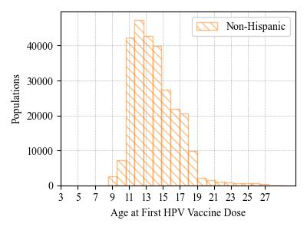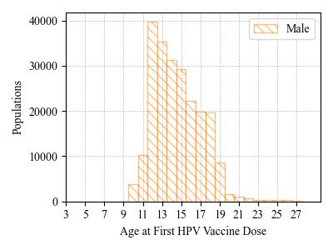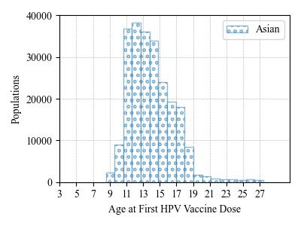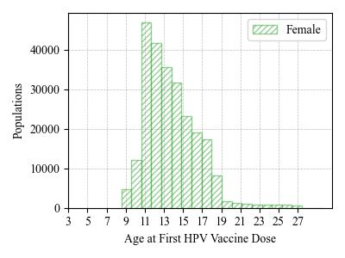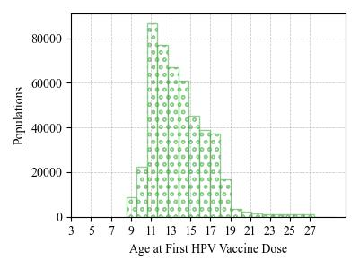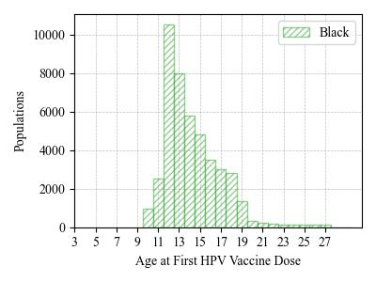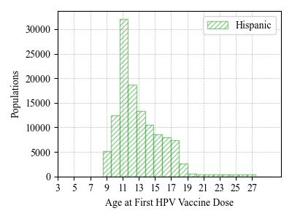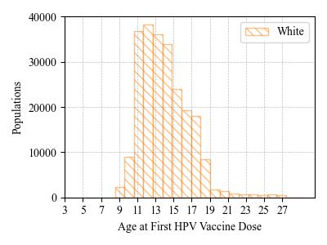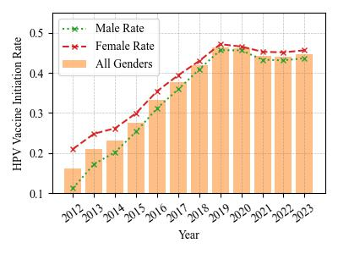

1. HPV vaccine initiation rate for LI children   
    ages 9-13 by race and ethnicity.

**Figure B**. HPV vaccine initiation rate among 9- to 13-year-old children in Nassau and Suffolk Counties, New York. The rate here was calculated by the number of children who already initialized the HPV vaccination divided by the number of children either receive the HPV vaccination or Tdap vaccination.

1. HPV vaccine initiation rate for LI children ages 9-13 by gender.
2. HPV vaccine initiation rate for Suffolk children ages 9-13 by gender.
3. HPV vaccine initiation rate for Nassau children ages 9-13 by gender.
4. HPV Vaccinated LI children ages 9-13 by Season

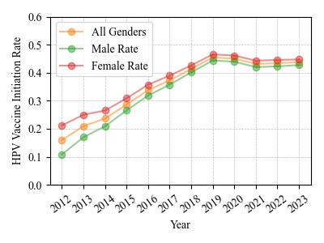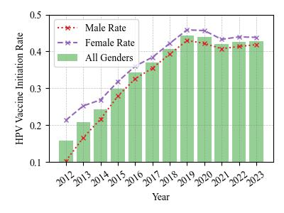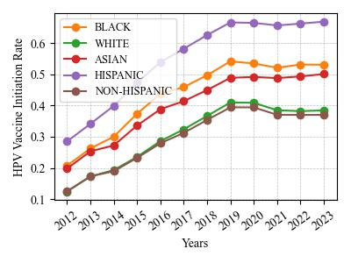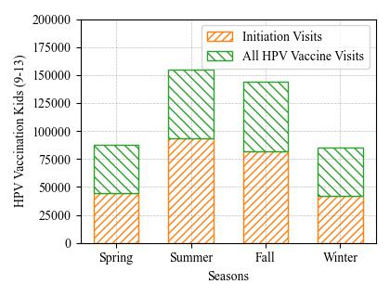

**Figure C.** The completeness of the HPV vaccinated individuals on the Long Island, New York State, 2012-2023. The figures are generated according to the CDC HPV vaccination guidelines.

1. The Nested Pie Chart shows the HPV Vaccination Patient Doses Schedule and Completeness Portion.

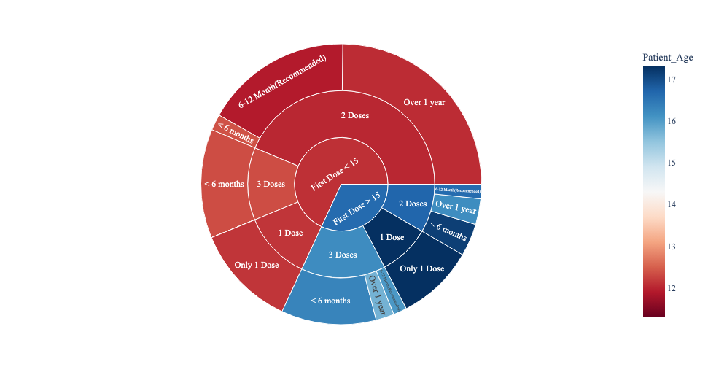

1. HPV Vaccine Series Completion by Gender
2. HPV Vaccine Series Completion by Race and Ethnicity

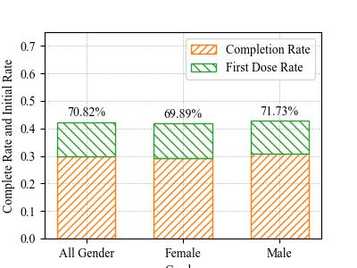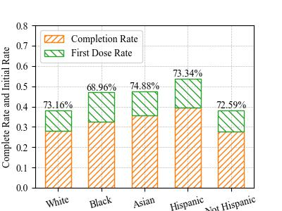

**Figure D**. Geographical maps of HPV vaccination rates on Long Island, New York (Nassau and Suffolk Counties) among children ages 9-13 by zip code. The rate was calculated by the number of children receiving one or more HPV vaccine dose divided by the number of children who received HPV, Tdap or both vaccines.

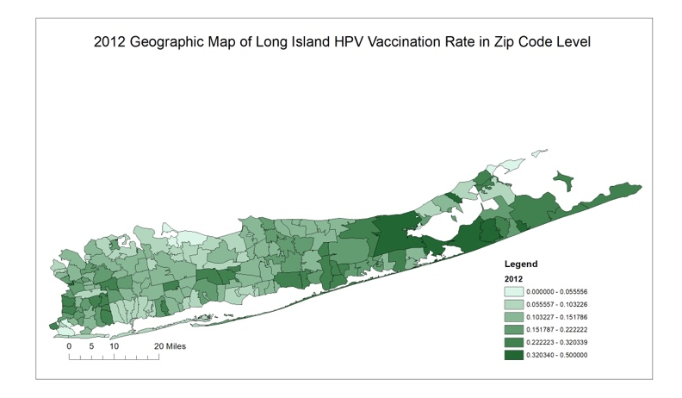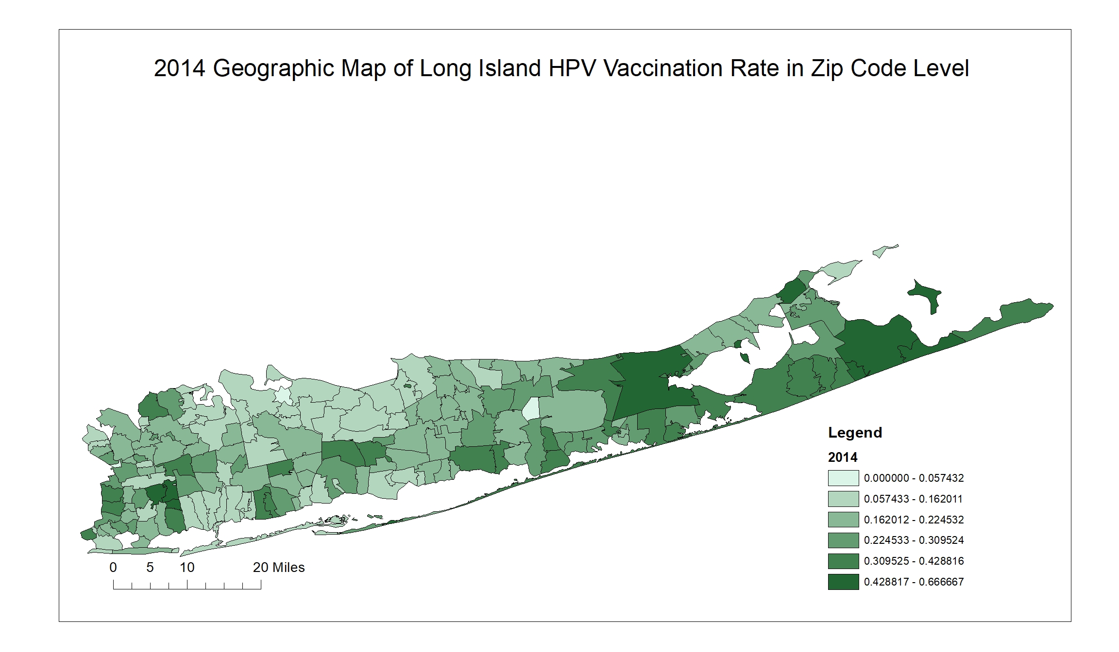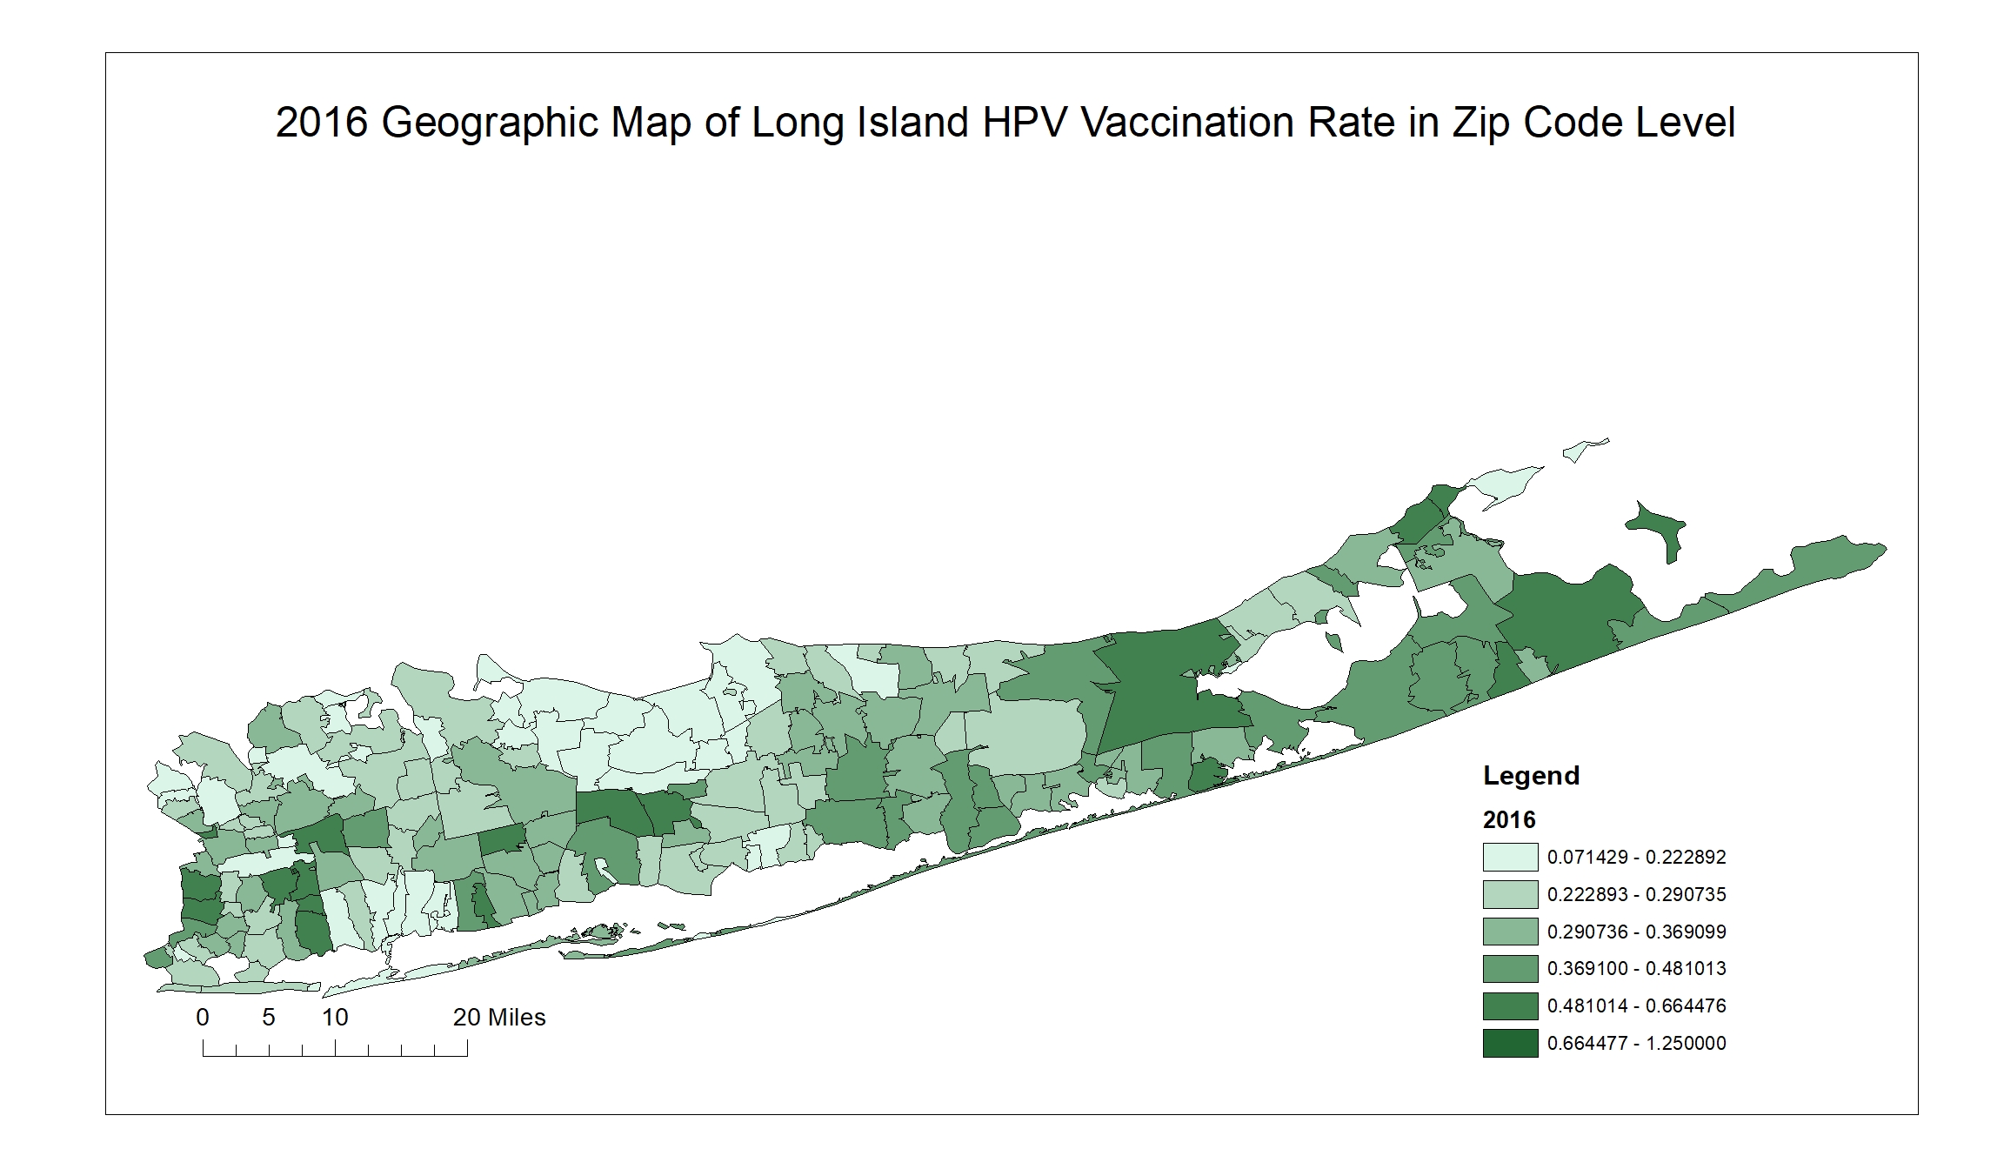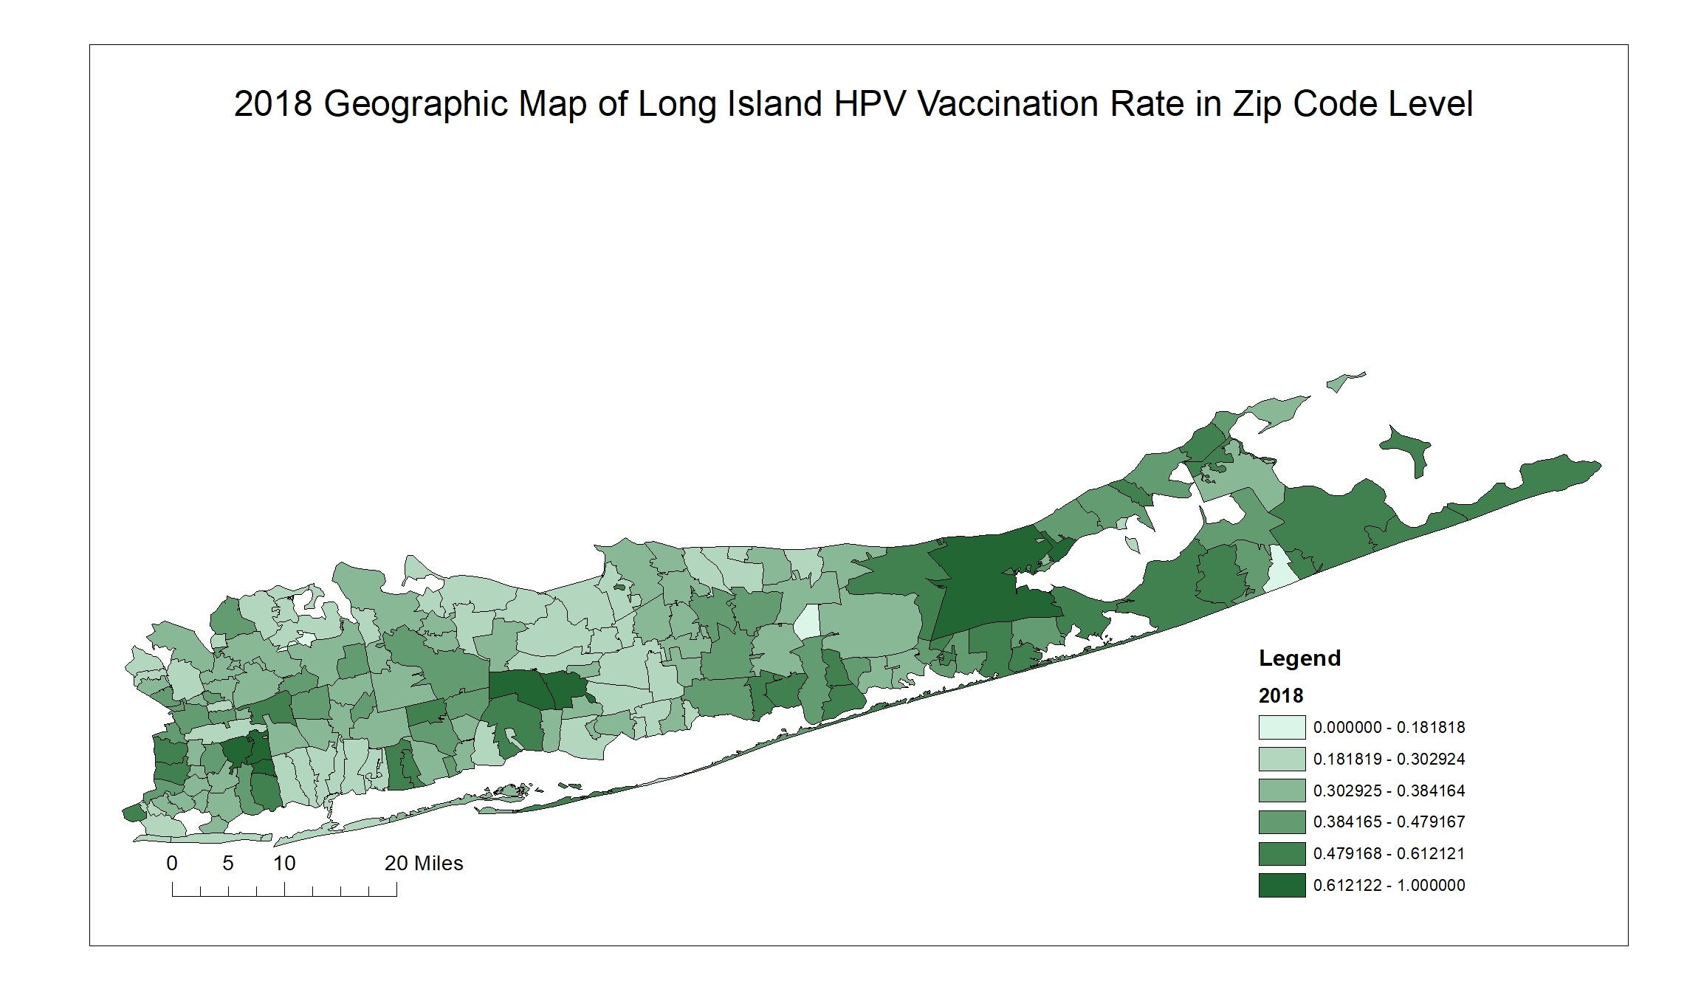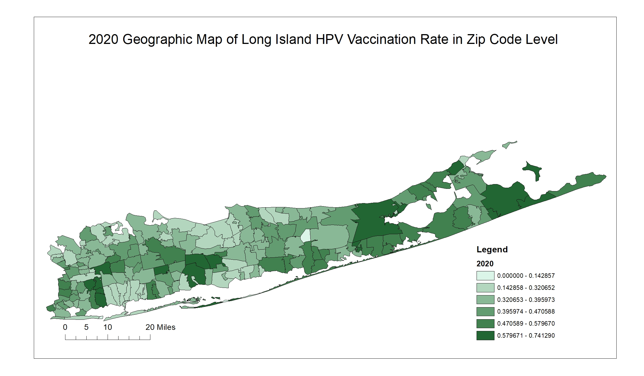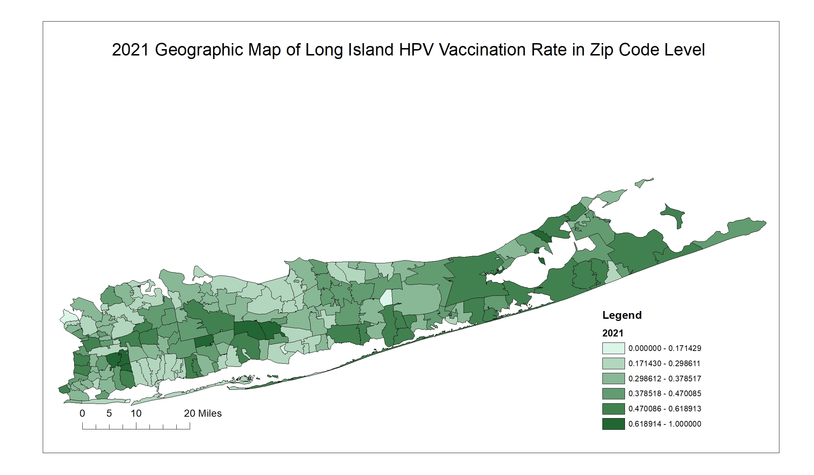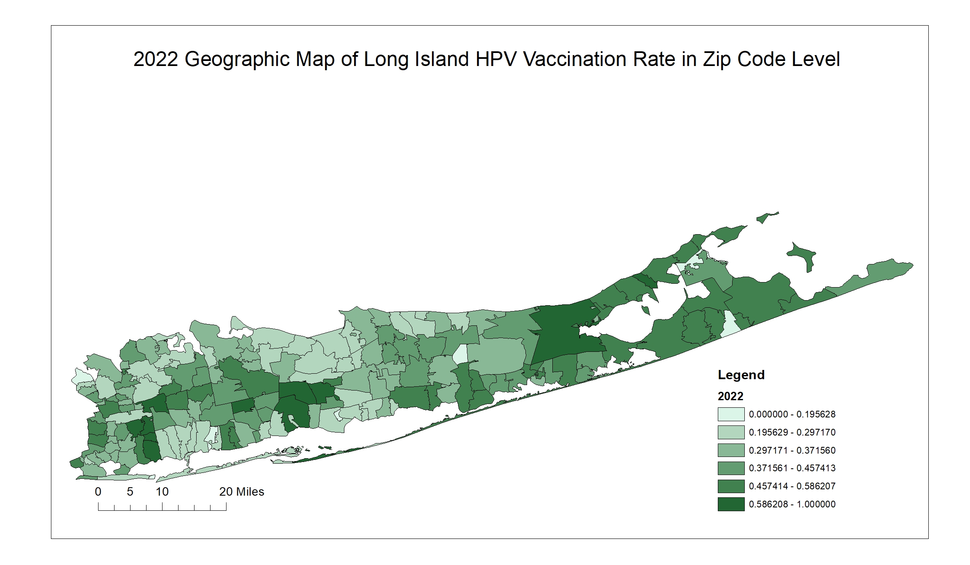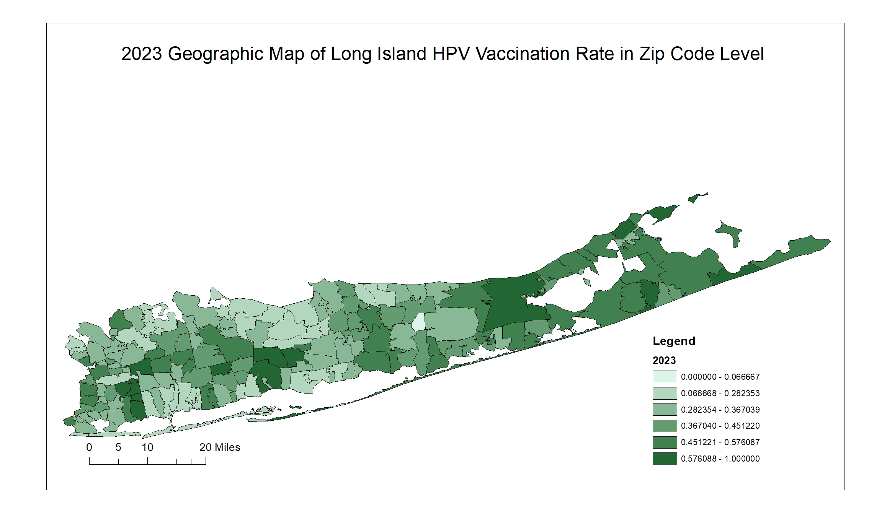

1. (2012) Geographic Map of Long Island HPV Vaccination Rate by Zip Code
2. (2016) Geographic Map of Long Island HPV Vaccination Rate by Zip Code
3. (2014) Geographic Map of Long Island HPV Vaccination Rate by Zip Code
4. (2018) Geographic Map of Long Island HPV Vaccination Rate by Zip Code
5. (2020) Geographic Map of Long Island HPV Vaccination Rate by Zip Code
6. (2021) Geographic Map of Long Island HPV Vaccination Rate by Zip Code
7. (2022) Geographic Map of Long Island HPV Vaccination Rate by Zip Code
8. (2023) Geographic Map of Long Island HPV Vaccination Rate by Zip Code